Custom Training

Day 12

**Power BI**

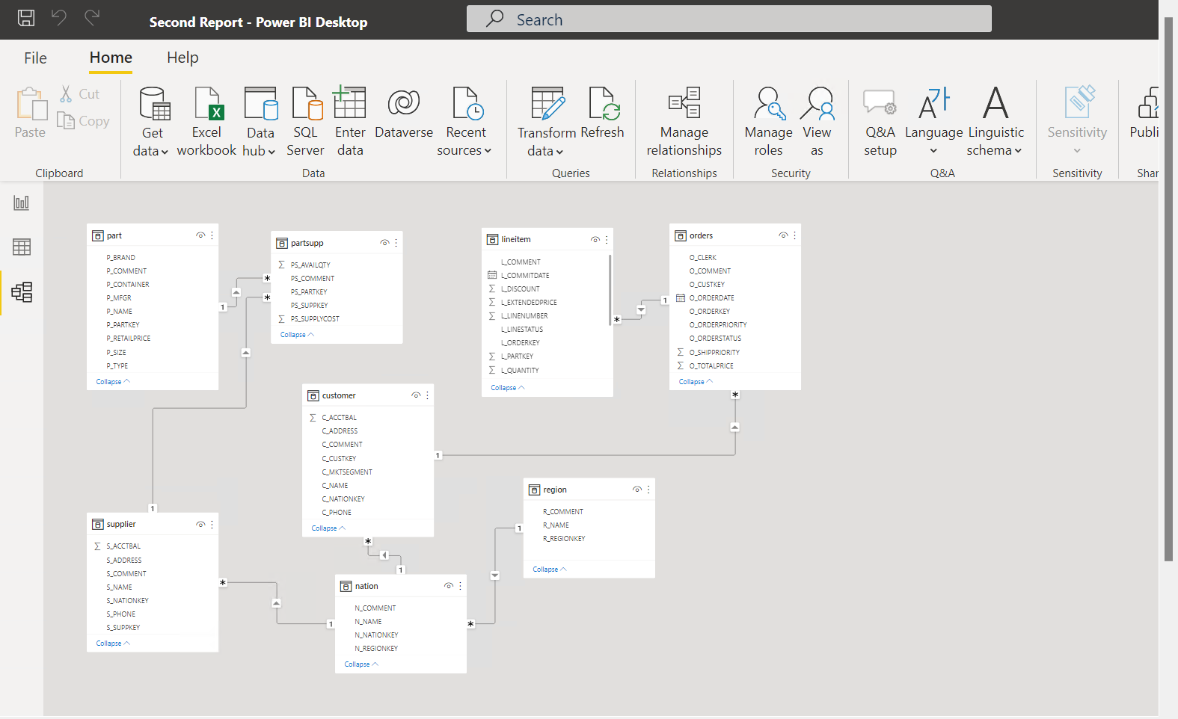

Univariant: Doing analysis based on only one variable.

Bivariant: Doing analysis based on two variables.

Multivariant: Doing analysis based on three variables.

Drill Through: We create to group logically related columns.

Hands-On Session:

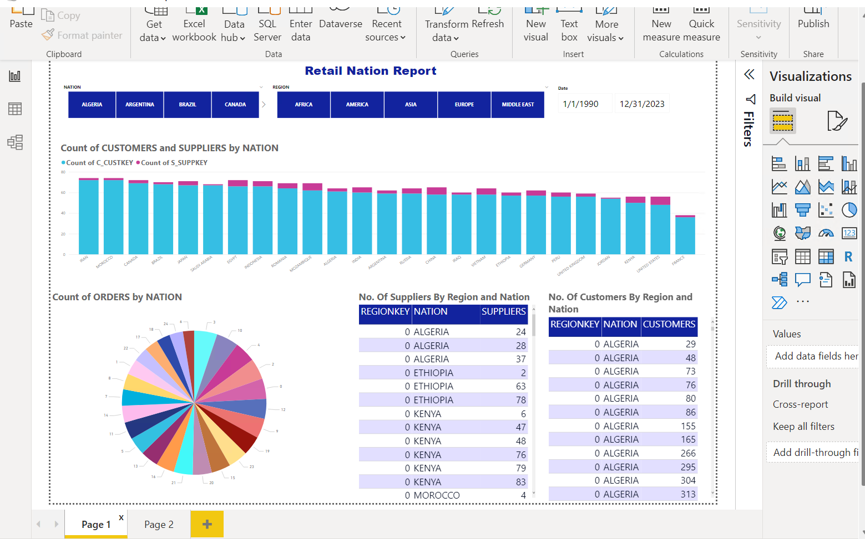

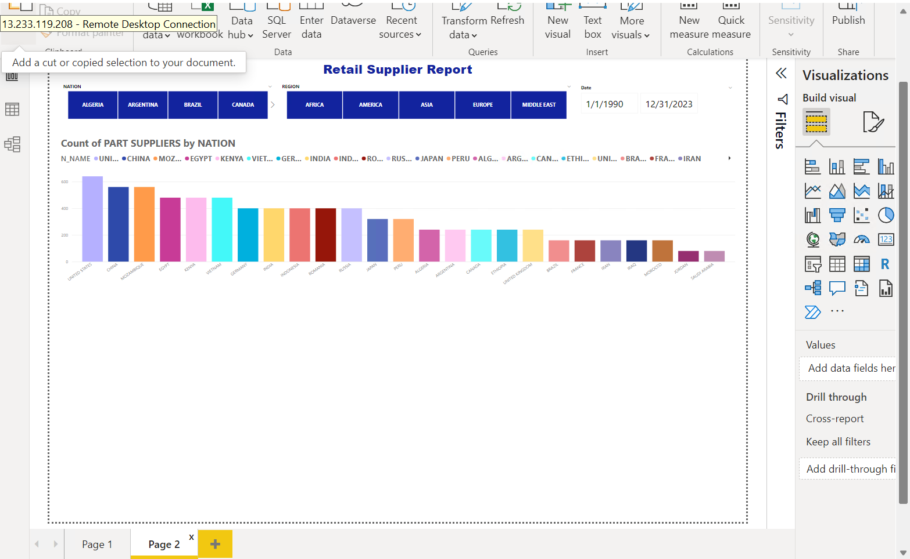

Case Study Report:

